Oak Park High School

Vocal Music Scholarship Application

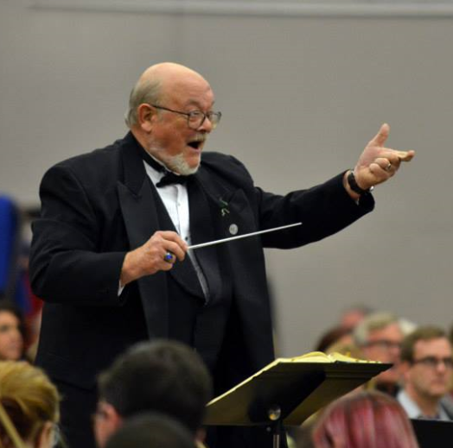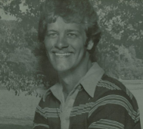

Two scholarships are given annually. A $500 scholarship honors former Vocal Music Director Bill Grace, and the other is the $250 Steve Overbey Memorial Scholarship. A committee of current and former Oak Park staff and an Overbey family member selects the recipients.

Deadline: Friday, April 8, 2016

Payment: Payment of the scholarship will be made directly to the institution you plan to attend. You must complete a minimum of one semester. If you withdraw before completing one semester, you must return the scholarship to the North Kansas City Schools Education Foundation, which holds the scholarship funds, and the first alternate will receive the scholarship.

Please submit your application to Chris Droegemueller, Oak Park High School, 825 N.E. 79th Terrace, Kansas City, MO 64118.

2016 Application Form
Oak Park Vocal Music Scholarship
Applying for (check one):

________ Bill Grace Scholarship _________ Steve Overbey Memorial Scholarship ________ Both

Part I

Applicant’s Name: ___________________________________________________________________
Age: __________________________________ Date of Birth: ________________________________
Address: ___________________________________________________________________________
City, State, Zip: _____________________________________________________________________
Home Phone: Cell: _________________________________
Personal E-mail: _____________________________________________________________________

1st Parent/Legal Guardian: _____________________________________________________________
Address (if different from above): _______________________________________________________
___________________________________________________________________________________
Place of Employment: Title: ___________________________
2nd Parent/Legal Guardian: _____________________________________________________________
Address (if different from above): _______________________________________________________
___________________________________________________________________________________
Place of Employment: Title: ___________________________
Number of children in family: __________________________________________________________

Number of siblings in college: __________________________________________________________

Part II
GPA: _________________________________ Class Rank _______________ of _________________
Vocal Music Classes Taken at Oak Park: ___________________________________________________________________________________
___________________________________________________________________________________
___________________________________________________________________________________
___________________________________________________________________________________
___________________________________________________________________________________

Part III
School Activities: ___________________________________________________________________________________
___________________________________________________________________________________
___________________________________________________________________________________
___________________________________________________________________________________
___________________________________________________________________________________

Elected Offices Held: ___________________________________________________________________________________
___________________________________________________________________________________
___________________________________________________________________________________
___________________________________________________________________________________
___________________________________________________________________________________

Activities Outside of School (non-Church): ___________________________________________________________________________________
___________________________________________________________________________________
___________________________________________________________________________________
___________________________________________________________________________________
___________________________________________________________________________________

Summer or Part-time Jobs: ___________________________________________________________________________________
___________________________________________________________________________________
___________________________________________________________________________________
___________________________________________________________________________________
___________________________________________________________________________________

Part IV
(Overbey Scholarship Only)
Church Preference: ___________________________________________________________________
Church Involvement: _________________________________________________________________
___________________________________________________________________________________
___________________________________________________________________________________

Part V

College or University Attending: _______________________________________________________
__________________________________________________________________________________
___________________________________________________________________________________

Part VI
Three Letters of Recommendation

_____________ Pastor or Youth Minister (Overbey Scholarship Only)
_____________ Oak Park Counselor or Teacher (Other than Vocal Music)
_____________ Non-School Person (Not a Relative)

Part VII
Personal Statement

On a separate page, write a statement of your goals, both educational and vocational.

I, _______________________________________________, hereby agree to complete this term for

which the scholarship was awarded or return the amount of the scholarship in full.

Signature of Applicant: Date: _____________________

Signature of Parent or Legal Guardian ____________________________________________

Date: ____________________________________________

